MODULE 1

**Electronic Circuits:**

* 1. **Power Supplies** – Block diagram Rectifiers

Reservoir and smoothing circuits Full-wave rectifiers

Bi-phase rectifier circuits Bridge rectifier circuits Voltage regulators

Output resistance and voltage regulation

Voltage multipliers

* 1. **Amplifiers** – Types of amplifiers Gain

Input and output resistance Frequency response Bandwidth

Phase shift Negative feedback

Multi-stage amplifiers

* 1. **Operational amplifiers** – Operational amplifier parameters Operational amplifier characteristics Operational amplifier configurations

Operational amplifier circuits

* 1. **Oscillators** – Positive feedback

Conditions for oscillation Ladder network oscillator Wein bridge oscillator Multivibrators

Single-stage astable oscillator Crystal controlled oscillators

# Block Diagram of DC Power Supplies

DC power supplies consist of main four stages.

**Step down transformer**: It is a device that has two coil windings: primary and secondary used to convert a high AC voltage (230V/ 50Hz) to a required low AC voltage.

**Rectifier**: It is a device has one or more diodes, converts secondary AC voltage to pulsating DC. **Smoothening Filter**: It is a circuit used to remove fluctuations (ripple or ac) present in rectifier output. Example: Capacitor filters, LC filters, π- filters, etc..

**Voltage Regulator:** Voltage regulator is a circuit which provides constant DC output voltage irrespective of changes in load current or changes in input voltage.

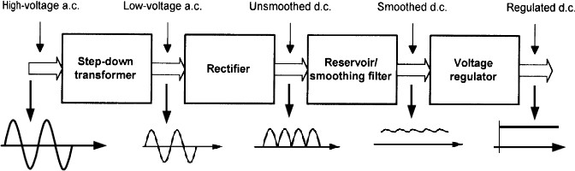

**Fig.1. Block diagram of a DC power supply**

Fig. 2, shows important electronic components that are used in the block diagram in fig. 1. Step-down transformer is made of iron core, feeds a rectifier. Rectifier output is applied to a high value capacitor to minimize ripples. Capacitor filter charges as the rectifier output voltage increases until its peak value. When the voltage value reduces, it discharges gradually through the regulator. Finally, a series transistor regulator and zener diode provides a constant output DC voltage.

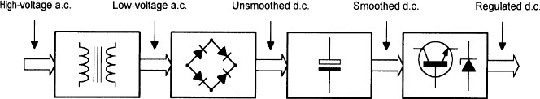

**Step-down Transformer Rectifier C Filter Voltage regulator Fig.2. Block diagram of a DC power supply showing principal components used in each stage**

# Rectifiers

Semiconductor diodes are commonly used as rectifiers. It converts AC voltage into rippled DC voltage. There are two types: Half-wave and full wave rectifiers.

Fig. 3 shows *half-wave* rectifier that allows one half of an AC waveform to pass through to the load. AC voltage (240V r.m.s) is applied to the primary of step-down transformer (T1). The secondary of T1,

reduces to 12V r.m.s. (Taking turns ratio: 240: 12 = 20:1). Diode D1 will allow current only in positive half cycle being forward biased and operates as a closed switch, see fig. 3(b). For negative half cycle, current will not allow passing through D1, because it is reverse biased and act like an open switch, see fig. 3(c).

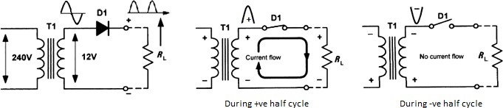

**Fig.3. (a) Half wave rectifier circuit (b) For + ve half cycle (closed switch) (c) For - ve half cycle (open switch)**

The switching action of D1 results in pulsating output voltage available at load resistor (*RL*). During positive half cycle, silicon diode will drop 0.6V to 0.7V as forward threshold voltage. During negative half cycle, D1 is reverse biased, hence secondary of T1 peak voltage will be dropped across it.

|  |  |
| --- | --- |
| **Analysis During +ve half cycle**:  Secondary of T1 = 12V r.m.s voltage Peak voltage across secondary windings: Vpeak = 1.414 x Vrms  = 1.414 x 12 = 16.968V ~ 17V  Silicon diode drop voltage = 0.7V Actual output voltage across load *RL*  = 17- 0.7 =16.3V | **Fig.4 Illustration of actual output voltage across load RL** |

# Smoothing (Reservoir) circuits

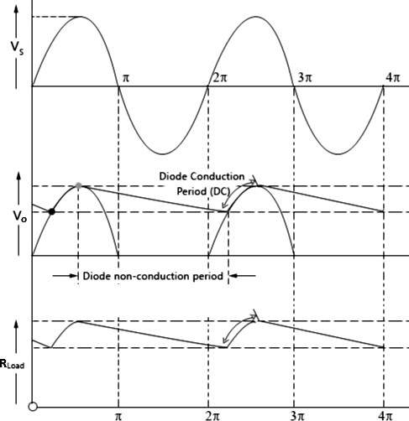

Smoothening circuit is a capacitor filter C1 connected in parallel to the load RL as shown in the fig.5. It is used to remove fluctuations (ripple or ac) present in rectifier output. When 240V AC voltage is applied to primary of T1, its secondary reduces to 12V r.m.s value and peak value is 16.3V.

|  |  |
| --- | --- |
| During +ve half cycle of secondary voltage, diode is forward biased, C1 charges as the rectifier output voltage increases to its peak value (16.3V).  When the rectifier voltage starts to decrease, C1 discharges slowly through the load RL, until the next  +ve half cycle is met. | **Vpeak = 16.3V**  Charging Discharging  Output voltage across RL |

**Fig. 5. a) Half wave smoothing circuit b) Input and output wave forms**

|  |  |
| --- | --- |
| Charging Time of C1 to the peak value = Rseries x C1 Rseries = Rsecondary winding + Rdiode + Rwiring and connections  Hence C1 charges quickly as soon as diode conducts. | Discharging Time of C1 = RL x C1  Practically, RL is very much larger than Rseries Hence C1 discharges slowly through RL. |

**Capacitor as reservoir:** C1 stores charge during +ve half cycle of secondary Vpeak and releases it during –ve half cycle, maintaining reasonably constant output voltage across RL. This causes to a small DC ripples at the output. The DC ripples can be drastically reduced by choosing a larger C1 value in place of smaller value.

**Improved ripple filters** In filers the value of the capacitor plays an important role in determining the output ripples and the average DC level. If the capacitor value is high, the amount of charge it can store will be high and the amount it discharges will be less. Thus the ripples will be less and the average dc level will be high.

**Limitations of C filter**

If the capacitor value is increased to a very high value, the amount of current required to charge the capacitor will be high. So, diodes are subjected to high surge currents. Thus, there is a limit in increasing the capacitor value in half-wave rectifiers.

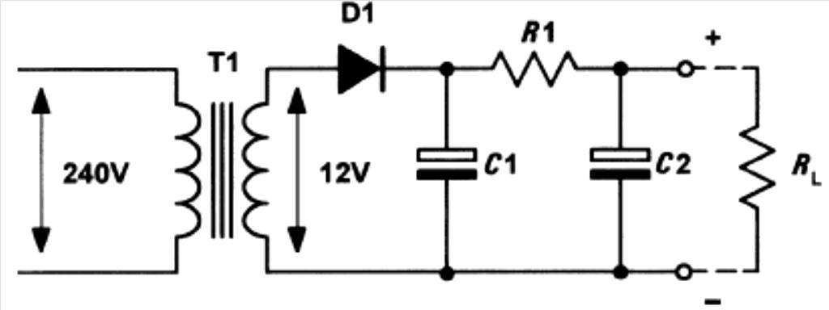**Refinement of C filter (RC filter)**

|  |  |
| --- | --- |
| Additional components R1 and C2 are connected as shown in the fig.6. C1 and C2 offer low reactance to AC components of ripple. In effect R1 and C2 act like a voltage divider and amount of ripple is reduced. But certain amount of DC voltage will drop across R1. The value of C2 is selected in such way that it exhibits negligible reactance at low frequencies  (50Hz – 100Hz). | **Fig.6. Half wave rectifier with R1 and C2** |

Amount of ripple reduction is determined by

X𝐶

√(𝑅2 + X2 )

Where, XC = reactance of C2.

* 1. 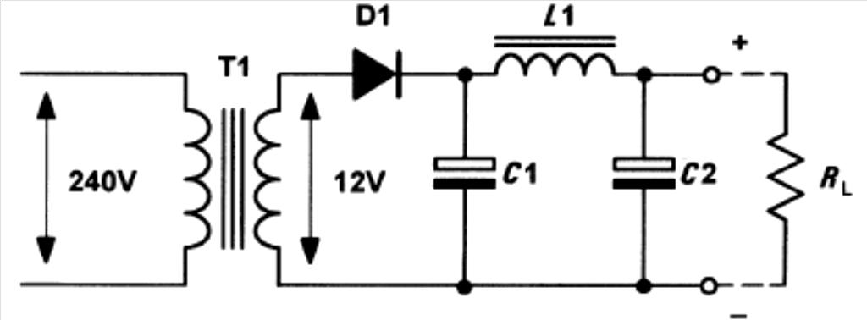**Smoothing Filter**

1 𝐶

|  |  |
| --- | --- |
| From the fig.7, at the ripple frequency, C1 exhibits low value of capacitive reactance. Hence it bypasses most of AC components of ripples. L1 exhibits high value of inductive reactance, therefore it allows most of DC components. Further, C1 bypasses remaining AC components offering low value of capacitive reactance. Thus the combined effect of L C greatly  reduces the ripples. | **Fig.7. Half wave rectifier with R1 and LC filter** |

**Advantage**: Half wave rectifier is cheap, simple and easy to construct.

## Disadvantage:

* + 1. Ripple factor is high at the output.
    2. Rectification efficiency is quite low, that means, power is delivered only during one half cycle of the input alternating voltage.
    3. Transformer utilization factor is low.

# Full-wave rectifiers

*Full-wave rectifier* – there are two types:

* *Bi-Phase or Center Tapped full wave rectifier* - uses two diodes and center tapped power transformer.
* *Bridge full wave rectifier* - uses four diodes and ordinary power transformer.

**Bi-phase Rectifier** The AC mains (240V) is applied to the primary of T1 which has two identical secondary windings each providing 12V r.m.s, as shown in the fig.8.

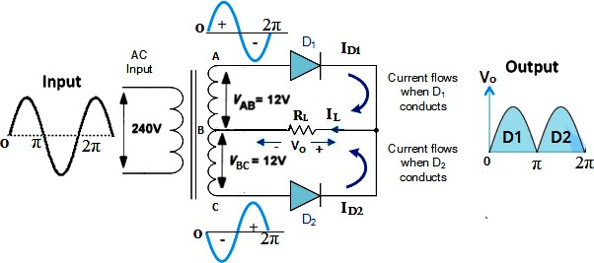

**Fig.8. Bi-phase rectifier circuit**

|  |  |
| --- | --- |
| On +ve half cycles, point A will be +ve with respect to point B. similarly, point B will be +ve with respect to point C.  D1 will forward bias, acts like a closed switch hence conducts. While D2 will reverse bias, acts like an open switch hence do not conduct. It is as shown in the fig. 9(a).  Thus, D1 alone conducts on +ve half cycles. | On -ve half cycles, point C will be +ve with respect to point B. similarly, point B will be +ve with respect to point A.  D2 will forward bias, acts like a closed switch hence conducts. While, D1 will reverse bias, acts like an open switch hence do not conduct. It is as shown in the fig. 9(b).  Thus, D2 alone conducts on -ve half cycles. |

**Fig.9. a) Bi-phase rectifier circuit for +ve half cycles b) Bi-phase rectifier circuit for -ve half cycles**

NOTE: i) Vpeak produced by each of secondary windings = 17V – 0.7V = 16.3V

ii) Pulses of voltage developed across RL = 100Hz (if primary is 50Hz)

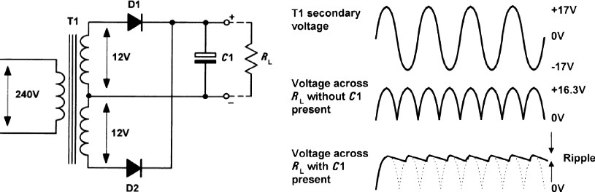**Bi-phase rectifier with C filter** Two diodes D1 and D2 are used in this circuit. They feed a common load resistor RL, with the help of a center tapped transformer as shown in the fig.10.

**Fig.10. a) Bi-phase rectifier with C1 filter b) Input output wave forms**

When diode D1 conduct, C1 charges to the peak value (16.3V) of the +ve half cycle. When diode D2 is in non-conducting state, C1 discharges slowly through the load RL. Similarly, when diode D2 conduct, C1 charges to the peak value of the -ve half cycle and C1 starts to discharge during diode D1 non-conducting state. Note that in this case capacitor C1 charge and discharge twice through RL during one full cycle.

|  |  |
| --- | --- |
| Charging Time of C1 to the peak value = Rseries x C1 Rseries = Rsecondary winding + Rdiode + Rwiring and connections  Hence C1 charges quickly as soon as diode conducts. | Discharging Time of C1 = RL x C1  Practically, RL is very much larger than Rseries Hence C1 discharges slowly through RL. |

## Disadvantages of Bi-phase Rectifier:

* + It is difficult to construct and locate the center-tap on secondary winding of the transformer.
  + The diodes used must have high PIV.

# Bridge Rectifier Circuits

Bridge full wave rectifier employs four diodes, but only two diodes will conduct during each half cycle.

|  |  |
| --- | --- |
| The AC mains (240V) is applied to the primary of T1 and secondary windings providing 12V r.m.s, as shown in the fig.11. |  |
| **Fig.11. a) Bridge rectifier b) Input output wave forms** | |

**6** Module – 1: Electronic Circuits BECE (21ELN14/24) EASWARA. M

During **positive half cycle**:

Point A will be +ve with respect to point B, then diodes D1D2 are forward biased act like closed switches, and hence conduct. While, diodes D3D4 are reverse biased act like open switches, hence do not conduct.

During **negative half cycle**:

Point B will be +ve with respect to point A, then diodes D3D4 are forward biased act like closed switches, and hence conduct. While, diodes D1D2 are reverse biased act like open switches, hence do not conduct.

In both +ve and –ve half cycles current IL flow through load resistance RL. The complete input-output voltage waveforms of the bridge full wave rectifier are shown in fig. 11(b).

Bridge rectifier with capacitor filter works very similar to that of bi-phase rectifier circuit.

# Voltage Regulators

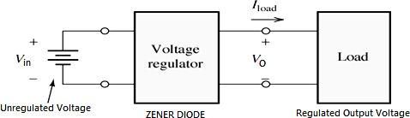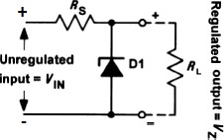Voltage regulator is a device by which output voltage *VO*, is maintained constant regardless of change in the input voltage *Vin* or load *RL.* The circuit diagram of the zener diode as a simple voltage regulator is shown in the fig.12.

**Fig.12. a) Simple block diagram of voltage regulator b) Zener diode shunt voltage regulator**

The series resistor, *RS* is connected in the circuit to limit the current through the zener diode to a safe value when load *R*L is disconnected. Also, the voltage drop across it is a part of unregulated input voltage, *Vin*. When *R*L is connected, zener current *I*Z will reduce as current (*I = Iz + IL*) is split into load *R*L.

Output voltage VO, remains constant until regulation fails. Regulation fails at a point at which potential divider formed by *R*S and *R*L produces lower voltage than VZ voltage.

𝑉Z

= 𝑉𝐼𝑁

× 𝑅𝐿

𝑅𝐿 + 𝑅𝑆

Series Resistor value (ohms) = (Vi – Vz) / (Zener current + load current). Maximum value of *R*S can be calculated as,

𝑍

𝑅𝑆𝑚𝑎𝑥 = 𝑅𝐿 × (𝑉𝐼𝑁

𝑉

𝑍

− 1) *and* 𝑅𝑆𝑚i𝑛 =

(𝑉𝐼𝑁𝑉𝑍)−𝑉2

𝑃𝑍𝑚𝑎𝑥

Also, 𝑅𝑚𝑎𝑥

= 𝑉i(𝑚i𝑛)− 𝑉z

𝐼𝐿(𝑚𝑎𝑥)+ 𝐼z(𝑚i𝑛)

𝑎𝑛𝑑 𝑅𝑚i𝑛

= 𝑉i(𝑚𝑎𝑥)− 𝑉z

𝐼𝐿(𝑚i𝑛)+ 𝐼z(𝑚𝑎𝑥)

The zener diode conducts the least current (Iz (min)) when the load current IL is maximum and it conducts the maximum current when the load current is minimum, *I = Iz + IL*.

The power dissipation of Zener diode is described as:

𝑃𝑧 = 𝑉𝑧𝐼𝑧(𝑚𝑎𝑥)

# Output resistance and voltage regulation

In a perfect power supply output voltage (VO), remain constant regardless of the current taken by the load. However practically, VO reduces as load current increases. This is due to *internal resistance* (ri) of the power supply. That means, this internal resistance appears at the output of the power supply. It is defined as

𝑅 = 𝐶ℎ𝑎𝑛𝑔𝑒 i𝑛 𝑉0 = 𝑑𝑉0

𝑜

The regulation of a power supply is given by

𝐶ℎ𝑎𝑛𝑔𝑒 i𝑛 𝐼𝐿

𝑑𝐼𝐿

𝑟𝑒𝑔𝑢𝑙𝑎𝑡i𝑜𝑛 = 𝐶ℎ𝑎𝑛𝑔𝑒 i𝑛 𝑉0

𝐶ℎ𝑎𝑛𝑔𝑒 i𝑛 𝑉𝐼𝑁

× 100 %

Ideally, the value of the regulation should be very small. Various regulators produce value of regulation as tabulated below:

|  |  |  |
| --- | --- | --- |
| **Sl.No** | **Type of regulator** | **Regulation in %** |
| 1 | Zener shunt | 5 to 10 |
| 2 | Sophisticated circuits based on  discrete components | 1 to 5 |
| 3 | Integrated Circuit (IC) | Lesser than 1% |

# Voltage multipliers

Voltage multiplier is a modified capacitor filter circuit that delivers a dc voltage twice or rnore times of the peak value of the input AC voltage. Such power supplies are used for high-voltage and low-current devices such as cathode-ray tubes (the picture tubes in TV receivers, oscilloscopes and computer display).

## Voltage Doubler

The circuit diagram for a full-wave voltage doubler is given in the fig.13. Assume in the beginning all capacitors are cleared (stored 0V).

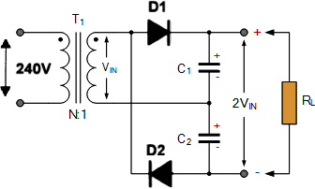During the +ve half cycle of VIN voltage, diode D1 gets forward biased (conducts) and charging the capacitor C1 to a peak voltage Vpeak with polarity indicated in the figure, while diode D2 is reverse-biased and does not conduct. During the -ve half-cycle, diode D2 being forward biased (conducts) and charges the capacitor C2 with polarity shown in the figure, while diode D1 does not conduct.

**Fig.13. Voltage Doubler circuit**

With no load connected to the output terminals, the output voltage will be equal to sum of voltages across capacitors C1 and C2. i.e., VC1 + VC2 = 2 VIN

When the load is connected to the output terminals, the output voltage VL will be less than 2 VIN.

Vout = 2VIN – voltages drop across diodes

## Voltage Tripler

The voltage doubler can be extended to produce 3 times voltages (Tripler) using the cascade arrangement shown in Fig. 14. Here C1 charges to the positive secondary voltage VIN, while C2 and C3 charge to twice the positive secondary voltage. The result is that the output voltage is the sum of the voltages across C1 and C3 which is three times the voltage that would be produced by a single diode.

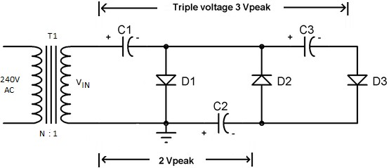

**Fig.14. Voltage Tripler circuit**

Assume in the beginning all capacitors are cleared (stored 0V).

During the first positive half cycle, diode D1 conducts (forward biased) and capacitor C1 gets charged the VIN of secondary.

During the negative half cycle, diode D2 is forward biased and diode D1 is reverse biased. D1 does not let discharge the capacitor C1, so voltage across C1 = VIN. The capacitor C2 gets charged with the combined voltage of C1 (VIN) and negative peak voltage of secondary voltage, so, C2 gets charged to 2VIN.

During the second positive half cycle, diode D1 and D3 conduct and D2 get reverse biased. So, the capacitor C2 charges the capacitor C3 up to 2VIN. Now, as we can see that the capacitors C1 and C3 are in series so the total voltage across these capacitors is VIN + 2VIN = 3VIN. This is how the tripled value of the applied voltage available at the output. Practically, some of the voltage drops across the diodes.

Vout = 3VIN – voltages drop across diodes

# Amplifiers

## Types of amplifiers

Amplifier is an electronic circuit which increases the amplitude of its input signal without changing other parameters.

### AC coupled amplifiers

In AC coupled amplifiers, stages are coupled together in such a way that DC levels are blocked and only the AC components of a signal are transferred from stage to stage.

### DC coupled amplifiers

In DC (or direct) coupled amplifiers, stages are coupled together in such a way that stages are not isolated to DC potentials. Both AC and DC signal components are transferred from stage to stage.

### Large-signal amplifiers

Large-signal amplifiers are designed to cater for appreciable voltage and/or current levels (typically from 1 V to 100 V or more).

### Small-signal amplifiers

Small-signal amplifiers are designed to cater for low-level signals (normally less than 1 V and often much smaller). Small-signal amplifiers have to be specially designed to combat the effects of noise.

### Audio frequency amplifiers

Audio frequency amplifiers operate in the band of frequencies that is normally associated with audio signals (e.g. the range of human hearing 20 Hz to 20 kHz).

### Wideband amplifiers

Wideband amplifiers are capable of amplifying a very wide range of frequencies, typically from a few tens of hertz to several megahertz.

### Radio frequency amplifiers

Radio frequency amplifiers operate in the band of frequencies that is normally associated with radio signals (e.g. from 100 kHz to over 1 GHz). Note that it is desirable for amplifiers of this type to be frequency selective and thus their frequency response may be restricted to a relatively narrow band of frequencies (see fig.15).

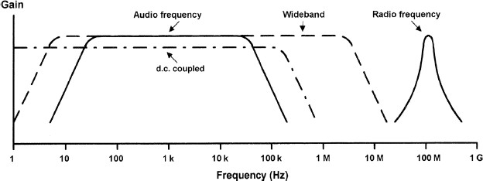

**Fig.15. Frequency response and bandwidth (output power plotted against frequency)**

### Low-noise amplifiers

Low-noise amplifiers are designed so that they contribute negligible noise (signal disturbance) to the signal being amplified. These amplifiers are usually designed for use with very small signal levels (usually less than 10 mV or so).

|  |  |  |
| --- | --- | --- |
| ***Voltage Amplifier***  The purpose of a voltage amplifier is to make the amplitude of the output voltage waveform greater than that of the input voltage waveform. | ***Current amplifier***  The purpose of a current amplifier is to make the amplitude of the output current waveform greater than that of the input current waveform. | ***Power amplifier***  In a power amplifier, the product of voltage and current (i.e. power  = voltage x current) at the output is greater than the product of voltage x current at the input. |

## Amplifier Parameters

* + - 1. **Gain**

The amount of amplification (or gain) is simply the ratio of output voltage to input voltage, output current to input current, or output power to input power (see Fig. 7.2). These three ratios give, respectively, the voltage gain, current gain and power gain.

|  |  |
| --- | --- |
| Voltage gain, 𝐴 = 𝑉𝑜𝑢𝑡  𝑉𝐼𝑁  Current gain, 𝐴 = 𝐼𝑜𝑢𝑡  𝐼𝐼𝑁  Power gain, 𝐴 = 𝑃𝑜𝑢𝑡  𝑃𝐼𝑁 |  |

Power is the product of current and voltage (*P* = *I V* ),



## Input resistance (Rin)

Input resistance is the ratio of input voltage to input current and it is expressed in Ω.

The input of an amplifier is normally purely resistive (i.e. any reactive component is negligible) in the middle of its working frequency range (i.e. the **mid-band**). In some cases, the reactance of the input may become appreciable (e.g. if a large value of stray capacitance appears in parallel with the input resistance). In such cases we would refer to **input impedance** rather than input resistance.

## Output resistance (Rout)

Output resistance is the ratio of open-circuit output voltage to short-circuit output current and is measured in Ω.

|  |  |
| --- | --- |
| As with input resistance, the output of an amplifier is normally purely resistive and we can safely ignore any reactive component. If this is not the case, we would once again need to refer to **output impedance** rather than output resistance.  [Note: This resistance is internal to the amplifier and should not be confused with the resistance of a load connected externally] |  |

**11** Module – 1: Electronic Circuits BECE (21ELN14/24) EASWARA. M

## Frequency response

It is the graph plotted for gain verses input frequency of an amplifier. The frequency response of an amplifier is usually specified in terms of the upper (f2) and lower (f1) cut-off frequencies of the amplifier. These frequencies are those at which the output power has dropped to 50% (otherwise known as the −**3 dB points**) or where the voltage gain has dropped to 70.7% of its mid-band value. Fig. 16 show how the bandwidth can be expressed in terms of either power or voltage.

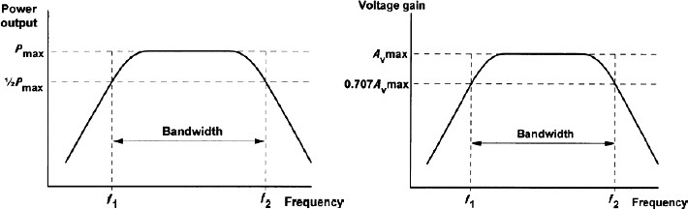

**Fig.16. Frequency response and bandwidth a) output power Vs frequency b) output voltage Vs frequency**

## Bandwidth

The bandwidth of an amplifier is usually taken as the difference between the upper and lower cut-off frequencies (i.e. *f*2 − *f*1 in Fig.16). The range of frequencies within a band is known as bandwidth.

**Example**: Audio amplifiers have a flat frequency response (as shown in fig.17) over the audio range of frequencies from 20 Hz to 20 kHz. This range of frequencies, for an audio amplifier is called its Bandwidth, (BW).

The bandwidth of an amplifier must be sufficient to accommodate the range of frequencies present within the signals that it is to be presented with.

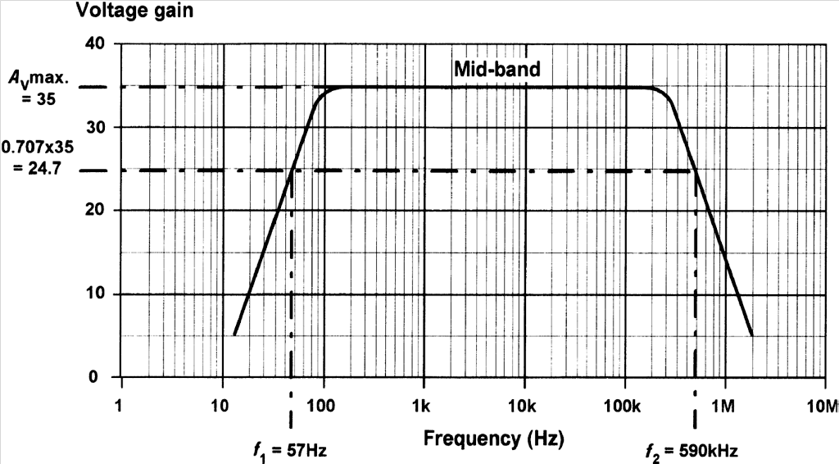

**Fig.17. Mid-band voltage gain, upper and lower cut-off frequencies of amplifier with frequency response**

## Phase shift

Phase shift is the phase angle between the input and output signal voltages measured in degrees. The measurement is usually carried out in the mid-band where, for most amplifiers, the phase shift remains relatively constant. Note also that conventional single-stage transistor amplifiers provide phase shifts of either 180° or 360°.

## Negative feedback

Many practical amplifiers use negative feedback in order to precisely control the gain, reduce distortion and improve bandwidth. The gain can be reduced to a manageable value by feeding back a small proportion of the output. The amount of feedback determines the overall (or **closed-loop**) gain. The form of feedback has the effect of reducing the overall gain of the circuit, is known as **negative feedback**.

An alternative form of feedback, where the output is fed back in such a way as to reinforce the input (rather than to subtract from it) is known as **positive feedback**.

|  |  |
| --- | --- |
| **Fig.18. Amplifier with negative feedback applied** | *A= Vo/Vin*  *Vo=A Vin*, where *Vin=VS –Vf*  and *Vf = βVo*  *Vo = A(Vs – βVo) Vo =AVs – A βVo Vo + A βVo =AVs AVs =Vo (1+Aβ)*  So, the equation of overall gain with negative feedback is given by |

Fig.18 shows the block diagram of an amplifier stage with negative feedback applied. In this circuit, the proportion of the output voltage fed back to the input is given by β and the overall voltage gain will be given by:

## Multi-stage amplifiers

𝑂𝑣𝑒𝑟𝑎𝑙𝑙 𝑔𝑎i𝑛, 𝐺 = 𝑉𝑜

𝑉𝑠

Output of first stage is connected to the input of the second stage through a suitable coupling device and so on. In order to provide sufficiently large values of gain, it is frequently necessary to use a number of interconnected stages within an amplifier.



The overall gain of an amplifier with several stages (i.e. a multi-stage amplifier) is simply the product of the individual voltage gains. Hence:

*A*V = *A*V1 × *A*V2 × *A*V3, etc.

Note, however, that the bandwidth of a multistage amplifier will be less than the bandwidth of each individual stage. In other words, an increase in gain can only be achieved at the expense of a reduction in bandwidth.

# Types of coupling

Coupling devices transfer energy from one stage to the other.

## In RC coupling

Resistor (R) used as load impedance and capacitor (C) is used as the coupling element. The capacitor (C) connects the output of one stage to the input of the next stage which allows the AC signal while blocking the DC voltages. Since the DC resistance of R is high, the efficiency of the amplifier is decreased.

**Disadvantage:** i) Causes loss for the low frequency signals.

ii) Difficult to match the impedance from stage to stage

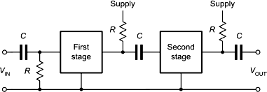

## In L–C coupling

Inductance (L) as load impedance and capacitance(C) used as coupling elements. The capacitor connects the output of one stage to the input of the next stage which allows the AC signal while blocking the DC voltages. The impedance of coupling coil (L) depends on its inductance and signal frequency. Since the DC resistance of the coil (L) is low, the efficiency of the amplifier is increased.

**Disadvantage:** only used in RF and high-frequency amplifiers.

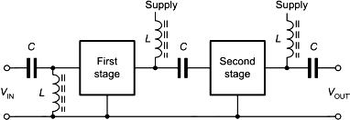

## In transformer coupling

Transformer is used as the coupling device. The transformer coupling provides two functions: i) to pass AC signal and blocking DC and ii) permits impedance matching.

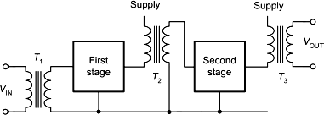

**Disadvantage**: i) Coupling transformer is expensive and bulky

1. Transformers tend to produce hum noise
2. It has a poor frequency response

# Operational amplifiers

The integrated-circuit *operational-amplifier* is the fundamental building block for many electronic circuits. An op-amp is a multi-stage, direct coupled, high gain negative feedback amplifier used to amplify AC and DC input signals.

* The main applications of op-amp:

Active filters, oscillators, peak detector, comparators, voltage regulators, precision rectifiers, instrumentation and control systems, pulse generators, square wave generators etc.

## PIN DIAGRAM OF µA 741

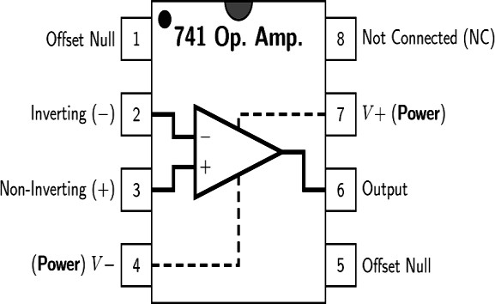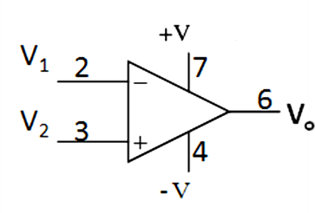Pin 2: Inverting (- ve) terminal Pin 3: Non-Inverting (+ve)

terminal

Pin 4: - ve power supply (- VEE) Pin 5: +ve power supply (+VCC) Pin 6: Output terminal (Vout)

Pins 1& 5: Offset null and pin 8: not connected (NC)

**Fig. 3.1 (a) Basic pin-out of Op-amp (b) circuit symbol (c) pin description**

The ‘+’ sign indicates zero phase shift while the ‘-’ sign indicates 180° phase shift. Since 180° phase shift produces an inverted waveform, the ‘-’ input is often referred to as the **inverting input**. Similarly, the ‘+’ input is known as the **non-inverting** input.

## Operational amplifier parameters

***Open-loop voltage gain***, (*Aol*):

It is the internal voltage gain of the device and represents the ratio of output voltage to input voltage when there are no external components.

Ideal value: **∞** Practical Value: **2 x 105**

The open-loop voltage gain is often expressed in **decibels** (**dB**) rather than as a ratio.

𝑂𝑝𝑒𝑛 𝑙𝑜𝑜𝑝 𝑔𝑎i𝑛 = 20𝑙𝑜𝑔 𝑉𝑜𝑢𝑡

𝑉i𝑛

Most operational amplifiers have open-loop voltage gains of 90 dB or more.

### Closed-loop voltage gain(Acl):

The closed-loop voltage gain of an operational amplifier is defined as the ratio of output voltage to input voltage measured with a small proportion of the output fed-back to the input (i.e. with feedback applied). The effect of providing negative feedback is to reduce the loop voltage gain. Value of *Acl* is very much less than value of *Aol*.

### Input resistance

𝐶𝑙𝑜𝑠𝑒𝑑 𝑙𝑜𝑜𝑝 𝑔𝑎i𝑛 = 𝑉𝑜𝑢𝑡

𝑉i𝑛

The input resistance of an operational amplifier is defined as the ratio of input voltage to input current expressed in ohms.

Ideal value: **∞** Practical value: 2 MΩ for bipolar operational amplifiers and 1012 Ω for CMOS operational amplifiers

𝑅𝐼𝑁

= 𝑉i𝑛

𝐼i𝑛

### Output resistance

The output resistance of an operational amplifier is defined as the ratio of open-circuit output voltage to short- circuit output current expressed in ohms.

Ideal value: 0, Practical values range from less than 10 Ω to around 100 Ω.

### Input offset voltage

𝑅0𝑈𝑇

= 𝑉𝑜𝑢𝑡(0𝐶)

𝐼𝑜𝑢𝑡(𝑆𝐶)

Practically, a small DC voltage will appear at the output of amplifier when no input voltage (or 0V) is applied. Thus, differential (very small) voltage is required between the inputs to make the output to 0V.

Input offset voltage may be minimized by applying relatively large amounts of negative feedback or by using the offset null facility provided by a number of operational amplifier devices.

Ideal value: 0 Typical values range from 1 mV to 15 mV.

### Full-power bandwidth

It is the **range of frequencies** at which the maximum undistorted Vpeak swing falls to 0.707 of its low- frequency (DC) value.

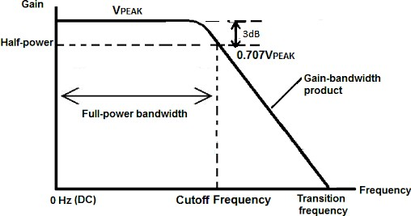Typical full-power bandwidths range from 10 kHz to over 1 MHz

### Slew Rate (SR)

The slew rate of an operational amplifier is the rate of change of output voltage with time in response to a perfect step-function input. Slew rate describes how fast the output voltage responds to an immediate change in input voltage. Slew rate is measured in V/s (or V/μs) and typical values range from 0.2 V/µs to over 20 V/µs.



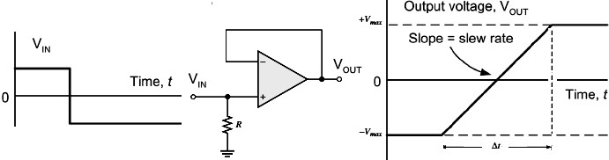

## Operational amplifier characteristics

Characteristics for an ‘ideal’ operational amplifier are:

1. The open-loop voltage gain should be very high (ideally infinite).
2. The input resistance should be very high (ideally infinite).
3. The output resistance should be very low (ideally zero).
4. Full-power bandwidth should be as wide as possible.
5. Slew rate should be as large as possible.
6. Input offset should be as small as possible.

## Comparison of operational amplifier parameters for ‘ideal’ and ‘real’ devices

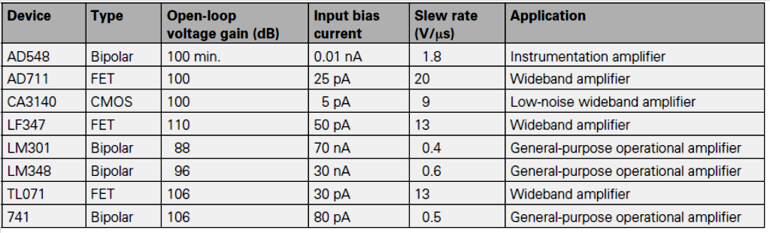**Some common examples of integrated circuit operational amplifiers**

## Operational amplifier configurations

* 1. **Inverting operational Amplifier**

Input signal Vin is applied to the inverting terminal of the amplifier and output Vout is inverted version (180o phase shift) of input Vin.

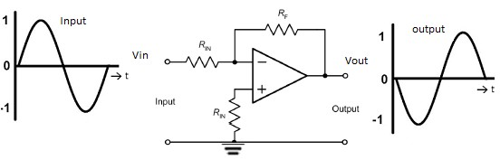

Vout = - Vin [ 𝑅𝐹 ]

𝑅i𝑛

## Non-inverting operational Amplifier

Input signal Vin is applied to the non-inverting terminal of the amplifier and output Vout is non-inverted version (0o phase shift) of input Vin.

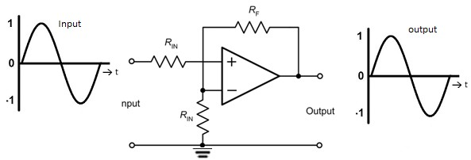

Vout = - Vin [ 𝑅𝐹 + 1]

𝑅i𝑛

## Differential amplifiers

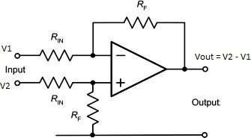Differential amplifiers amplify the difference between two input voltage signals of V1 and V2.

Vout = V2 – V1

## Effect of input and feedback capacitors

By selecting appropriate values of capacitor, the frequency response of an inverting operational voltage amplifier may be very easily modified to suit a particular set of requirements. The lower cut-off frequency is determined by the value of the input capacitance, *C*IN, and input resistance, *R*IN.



The upper cut-off frequency will be determined by the feedback capacitance, *C*F, and feedback resistance, *R*F,



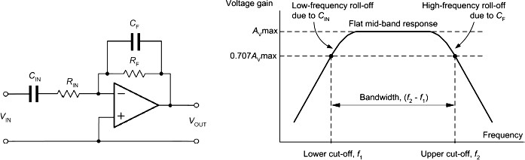

**Fig.19 Effect of adding capacitors, *C*IN and *C*F, to modify the frequency response of an operational amplifier**

# Operational amplifier circuits

## Voltage follower OPAMP

Output voltage Vout follows the input voltage Vin so the circuit is named as op-amp voltage follower. The output is connected directly back to the (-) inverting input so that the feedback is 100% and Vin is exactly equal to Vout . It is shown in the fig. If voltage Vin increases, voltage Vout increases. On the other hand, if voltage Vin decreases, voltage Vout also decreases. It provides an effective isolation of the output from the signal source that eliminating the loading effect of the second circuit from the first circuit.

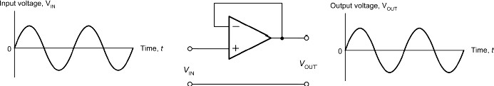

**Properties of Voltage follower**

Vout = VIN

* Voltage gain = 1
* Input impedance Rin = ∞
* Output impedance Rout = 0
* Effective isolation of the output from the signal source.

**Differentiator amplifier**

*Differentiator produces* output voltage (Vout) is proportional to the rate of change of the input voltage Vin. An op-amp differentiator is an inverting amplifier, which uses a capacitor C in series with the input voltage Vin and a feedback resistor R is connected between Vout and inverting (-) input.

V = − RC 𝑑 (𝑉 )

out

𝑑𝑡

i𝑛

If input is a square wave to a differentiator, output is pulses.

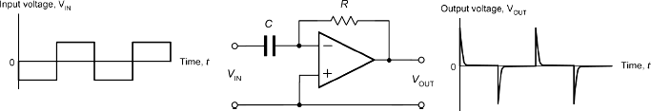

**Integrator Amplifier**

*Integrator produces* output voltage Vout, is proportional to the integral of the input voltage Vin. An op-amp i*ntegrator* is an inverting amplifier, which uses a resistor R in series with the input voltage Vin and a capacitor C is connected between Vout and inverting (-) input as feedback.

Vout

= − 1

𝐶𝑅

∫ 𝑉i𝑛

𝑑𝑡

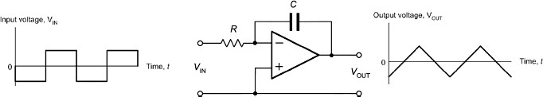If input is a square wave, output of an integrator is a triangular (inverted) wave.

**Comparator**

OPAMP voltage comparator compares the magnitudes of two voltage inputs and determines which is the larger of the two.

* Referring the fig.3.11, assume ( VIN < VREF ).
* As the non-inverting (positive) input of the comparator is less than the inverting (negative) input, the output will be the negative supply voltage, -Vcc resulting in a negative saturation of the output.
* When (VIN > VREF) , the output voltage rapidly switches HIGH towards the positive supply voltage, +Vcc resulting in a positive saturation of the output.

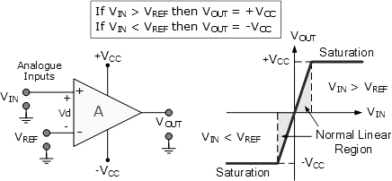

**Voltage comparator using OPAMP**

* Suppose the input voltage VIN, is decreased slightly less than VREF, the op-amp’s output switches back to its negative saturation voltage acting as a threshold detector.

Then it is seen that the op-amp voltage comparator is a device whose output is dependent on the value of the input voltages.

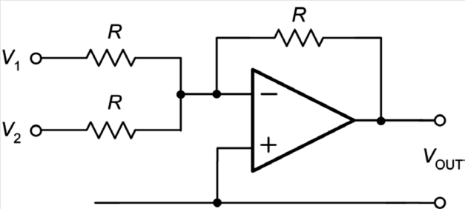**Summing Opamp**

|  |  |
| --- | --- |
| The inverting summing or adder op-amp circuit for three inputs is shown in the fig. 3.7.  The output voltage, Vout is proportional to the algebraic sum of the input voltages, V1, V2. Input signals V1 and V2 are applied to the inverting input of the op-amp through input resistors.  Vout = - (V1 + V2) | **Inverting summing op-amp circuit** |

# Oscillators

Negative feedback can be applied to an *amplifier* to form the basis of a stage which has a precisely controlled gain. Similarly, positive feedback can be applied to an *oscillator*, where the output is fed back in such a way as to reinforce the input.

## Positive feedback

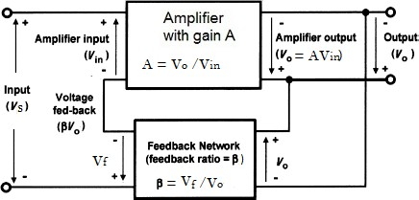Fig. 20, shows the block diagram of an amplifier stage with positive feedback applied. Note that the amplifier provides a phase shift of 180° and the feedback network provides a further 180°. Thus the overall phase shift is 0°.

|  |  |
| --- | --- |
| **Fig.20 Amplifier with positive feedback applied** | *A= Vo/Vin*  *Vo=A Vin*, where *Vin=VS +Vf*  and *Vf = βVo*  *Vo = A(Vs +βVo) Vo =AVs + A βVo Vo - A βVo =AVs AVs =Vo (1-Aβ)*  So, the equation of overall gain with negative feedback is given by |

The overall voltage gain, *G*, is given by:

Now consider what will happen when the loop gain, β*A*v, approaches just less than 1 (say, 0.99). The denominator (1 - β*A*v) will become close to zero. This will have the effect of *increasing* the overall gain, i.e. the overall gain with positive feedback applied will be *greater* than the gain without feedback.

**Illustration of effect of negative and positive feedback upon overall voltage gain**

|  |  |  |
| --- | --- | --- |
| Amplifier gain  *A*v = 9  feedback, β = 0.1 | **Overall voltage gain with negative feedback** | **Overall voltage gain with positive feedback** |
|  |  |
| Amplifier gain  *A*v = 10  feedback, β = 0.1 |  |  |

**Conditions for oscillation** (**Barkhausen's criteria for oscillation**)

Oscillator is a device that generates continuous and periodic waveforms without taking input signal. The conditions for oscillation are:

1. the feedback must be positive

(i.e. the phase shift must be 0o or 360o.);

1. the overall loop voltage gain must be greater than 1

(i.e. the amplifier’s gain must be sufficient to overcome the losses associated with any frequency selective feedback network). Hence, to create an oscillator we simply need an *amplifier* with sufficient gain to overcome the losses of the network that provide *positive feedback*.

# RC Ladder oscillator

RC Phase shift oscillator shown in fig.21, consists of a BJT amplifier (TR1) and three *RC* sections of phase shift network. At some particular frequency *f*0, the phase shift in each *RC* section is 60º so that the total phase-shift produced by the *RC* network is 180º. Amplifier produces another 180º phase shift. As a result, the phase shift around the entire loop is 360º.

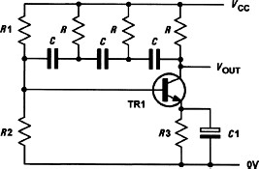

**Fig.21 Sine wave oscillator based on a three stage *C*–*R* ladder network**

𝐹𝑟𝑒𝑞𝑢𝑒𝑛𝑐𝑦 𝑜ƒ 𝑜𝑠𝑐i𝑙𝑙𝑎𝑡i𝑜𝑛𝑠 𝑜ƒ 𝑡ℎ𝑒 𝑐i𝑟𝑐𝑢i𝑡 i𝑠, ƒ𝑜

= 1

2𝜋𝑅𝐶√6

For oscillations to occur, |𝛽| > 1

29

That means, the loss associated with the ladder network is 29, thus the amplifier must provide a gain of *at least* 29 in order for the circuit to oscillate.

# Wien bridge oscillator

The output of the OPAMP is fed back to *Wien* bridge feedback circuit with respect to points ***A*** and ***B***as shown in fig.22. Points ***C*** and ***D*** provide – ve and + ve inputs to the OPAMP. A phase shift of 180º is produced by inverting OPAMP. A further phase shift of 180º is produced by the *RC* feedback bridge circuit. As a result, the phase shift around the entire loop is 360º.

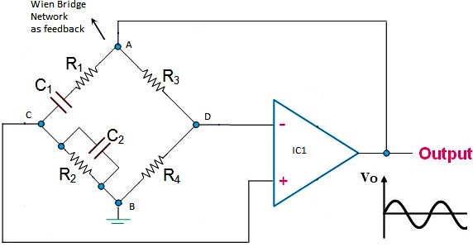

**Fig.22 Sine wave oscillator based on a Wien bridge Oscillator**

Particular frequency at which the values of the [resistance](https://www.electrical4u.com/electrical-resistance-and-laws-of-resistance/) and the capacitive reactance will become equal, producing maximum output voltage.

𝐹𝑟𝑒𝑞𝑢𝑒𝑛𝑐𝑦 𝑜ƒ 𝑜𝑠𝑐i𝑙𝑙𝑎𝑡i𝑜𝑛𝑠 i𝑠 ƒ𝑜

= 1

2𝜋√𝑅1𝑅2𝐶1𝐶2

= 1

2𝜋√𝑅𝐶

; iƒ 𝑅1 = 𝑅2 = 𝑅 𝑎𝑛𝑑 𝐶1 = 𝐶2 = 𝐶

The minimum amplifier gain required to sustain oscillation is given by



In most cases, *C*1 = *C* 2 and *R*1 = *R*2, hence the minimum amplifier gain will be 3.

# Multivibrators

Multivibrators are a family of oscillator circuits that produce output waveforms consisting of one or more rectangular pulses. The term ‘multivibrator’ simply originates from the fact that this type of waveform is rich in harmonics (i.e. ‘multiple vibrations’).

Multivibrators use regenerative (i.e. positive) feedback; the active devices present within the oscillator circuit being operated as switches, being alternately cut-off and driven into saturation.

The principal types of multivibrator are:

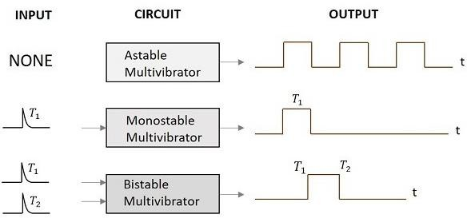

1. **Astable multivibrators** that provide a continuous train of pulses (these are sometimes also referred to as free-running multivibrators);
2. **Monostable multivibrators** that produce a single output pulse (they have one stable state and are thus sometimes also referred to as ‘one-shot’);
3. **Bistable multivibrators** that have two stable states and require a trigger pulse or control signal to change from one state (T1) to another (T2).

# Single-stage astable oscillator

An astable oscillator that produces a square wave output can be built using one operational amplifier, as shown in Fig. 23. The circuit employs positive feedback with the output fed back to the non-inverting input via the potential divider formed by *R*1 and *R*2.

|  |  |
| --- | --- |
| **When VO = +VCC , capacitor charges towards VUT** | **When VO = -VCC , capacitor charges towards VLT** |

**Fig. 23 Single-stage astable oscillator using an operational amplifier**

When power is turned ON, output VO normally swings either to +Vcc or to -Vcc.

**Assume**: i) *C* is initially uncharged

ii) VO = +*V*CC

The upper threshold voltage (the maximum +ve value at the inverting input) will be given by:

The lower threshold voltage (the maximum -ve value at the inverting input) will be given by:



Capacitor *C* charges through *R* and the voltage VC rise exponentially. As voltage across the capacitor is just greater than VUT, the output voltage will rapidly fall to −*V*CC.

Capacitor *C* will then start to discharge through R and the voltage VC, fall exponentially. As voltage across the capacitor is slightly lesser than VLT, the output voltage will rise rapidly to +*V*CC.

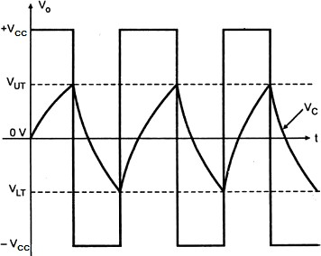This cycle will continue indefinitely.

Finally, the time for one complete cycle of the output waveform produced by the astable oscillator is given by:



# Crystal controlled oscillators

To obtain a very high level of oscillator stability a *Quartz Crystal* is generally used as the frequency determining device to produce high frequency stability in oscillators. Such oscillators are called as crystal oscillators.

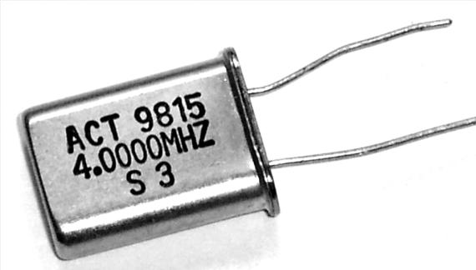The quartz crystal (a thin slice of quartz in a hermetically sealed enclosure, see Fig.) vibrates whenever a potential difference is applied across its faces (this phenomenon is known as the *piezoelectric effect*). The frequency of oscillation is determined by the crystal’s ‘cut’ and physical size.

Crystals can be manufactured for operation in **fundamental mode** over a frequency range extending from 100 kHz to around 20 MHz.

**REVIEW QUESTIONS**

**PART-1: POWER SUPPLIES**

1. What is a regulated power supply? With neat block diagram explain the working of DC power supply. Also mention the principal components used in each block.
2. With neat circuit diagram and waveforms explain half wave rectifier and full wave bridge rectifiers.
3. Define rectifier. Explain a biphase full wave rectifier. Show the appropriate waveforms.
4. Discuss the need of filter circuit. With circuit diagram and waveforms explain the operation of smoothing C – filter for half wave rectifier.
5. What is voltage regulator? With neat circuit diagram, explain the operation of a voltage regulator using zener diode.
6. A mains transformer having a turns ratio of 22:1 is connected to a 220 V r.m.s. mains supply. If the secondary output is applied to a half-wave rectifier, determine i) secondary r.m.s voltage ii) peak voltage and iii) regulated DC voltage across load.
7. A half wave rectifier uses a silicon diode is fed from a supply of 240 V, 50 Hz with step down transformer of ratio 3:1. Resistive load connected is 10 KΩ. The diode forward resistance is 75Ω and transformer secondary is 10 Ω. Calculate i) secondary r.m.s voltage ii) peak voltage and iii) regulated DC voltage across load.
8. The RC smoothing filter in a 50 Hz mains operated a half-wave rectifier circuit consists of *R*1 = 150Ω and *C*2 = 1,000F. If 1 V of ripple appears at the input of the circuit, determine the amount of ripple appearing at the output.
9. A 5V zener diode has a maximum rated power dissipation of 500 mW. If the diode is to be used in a simple regulator circuit to supply a regulated 5V to a load having a resistance of 500 Ω, determine a suitable value of series resistor for operation in conjunction with a supply of 9V.
10. What is voltage multiplier? With circuit diagram explain the operation of voltage doubler.

**PART-2: AMPLFIERS**

1. What is an amplifier? Explain the types of amplifiers.
2. Explain the parameters (characteristics) of amplifier.
3. What is the need of coupling? Explain the types of coupling in multi-stage amplifiers.
4. Mention advantages of negative feedback in amplifiers circuits. With relevant equations and diagram explain the concept of negative feedback.
5. Write a note on frequency response characteristics of an amplifier circuit, clearly mentioning the half power frequencies

**PART-3: OPERATIONAL AMPLFIERS (OPAMPS)**

1. Explain characteristics of OPAMP with practical (real) values.
2. Draw neat circuit diagram, input output waveforms and output voltage expressions of the following OPAMPs i) inverting amplifier, ii) non-inverting amplifier, iii) differentiator iv) integrator and v) summing amplifier.
3. Sketch the circuit of each of the following based on the use of operational amplifiers
   1. comparator (b) a differentiator (c) an integrator (d) Inverting Amplifier.
4. With circuit diagram explain OPAMP voltage follower.
5. With circuit diagram and waveform show how operational amplifier can work as a comparator

**PART-4: OSCILLATORS**

1. What is feedback system? With neat diagrams explain the types of feedback systems
2. Explain the criteria for oscillations.
3. Explain the operation of a three-stage ladder RC network oscillator and Wein bridge oscillator.
4. Determine the frequency of oscillation of a three-stage ladder RC network oscillator in which C =10 ηF

and R = 10 kΩ.

1. The frequency sensitivity arms of the Wein bridge oscillator uses C1 = C2 = 0.01μF and R1=10KΩ while R2 is kept variable. The frequency is to be varied from 10 KHz to 50 KHz by varying R2. Find the minimum and maximum values of R2.

With suitable diagrams explain single stage astable multi-vibrator using operational amplifier.